Chapter One: EML 4551C

1.3 Functional Decomposition
After talking with our sponsor, the team was able to clarify the project scope and what the customer needs for the project. Functional decomposition was utilized to interpret the needs of the project into systems, to find the necessary components that will satisfy the customer. One thing to keep in mind is that we are not breaking down all the macroscopic battery cooling functions. This is because we are not focusing on coolant pumps and systems outside the module. Our customer is allowing us to lightly consider the outer cooling systems, but he mainly would like us to focus on how cooling takes place inside the battery modules. The hierarchy chart and cross reference table below help break down the functions we are considering inside the battery modules. They serve to separate and clarify each function we must consider when developing our own cooling concepts.
Hierarchy Chart
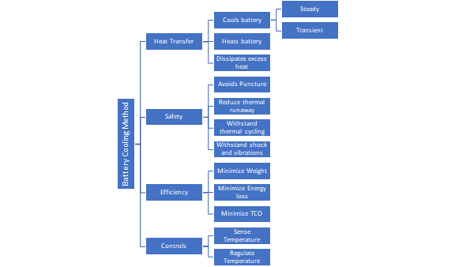
The hierarchy chart represents the total breakdown of the cooling system. Our project is broken into four categories: Heat Transfer, Safety, and Efficiency and Controls. The Heat Transfer system is responsible for cooling and heating the battery, the main function of the project. Safety, Efficiency, and Controls are systems that we must satisfy and consider while modifying the transfer of heat throughout the system. The heat transfer system must cool the battery during transient conditions to improve efficiency and maintain safety. It must also heat the battery in the case of cold weather conditions to maintain efficiency. Also, the cooling system must be able to maintain a relatively low temperature during transient conditions such as vehicle braking and acceleration (battery charging and discharging). The safety system is related to the heat transfer system in that the cooling of the battery helps prevent battery puncture due to high heat. The safety system also includes shock and vibration resistance as these factors can also cause battery cell punctures. The efficiency system is broken down into weight reduction, energy loss minimization, and total cost of ownership reduction. These systems are based off specific requirements clarified by the customer. Finally, the controls system involves the communication between the battery control module and the thermal sensors in the battery. We must consider how these communicate and how the BCM reacts to temperature change within the battery.

Figure 1: Function Decomposition Hierarchy

Integration
The cross-reference table shown below was made to identify how each of the functions has an influence on different major systems. This helps to identify how each function can affect other major systems that they are not grouped under. For example, the function “Withstand Thermal Cycling” has influence on Heat Transfer, Safety, and Efficiency systems. As the battery is used the cells our design will experience thermal cycling and this will impact how the design can transfer heat, how efficient the design will be, and has implications on the safety of the design. Each of the functions that falls under multiple systems provides integration between the systems. This will allow our design to meet all the aspects we are trying to meet by relating the transfer of heat to the efficiency of the design, to the safe operation of the design, and to the controls that regulate the system. The more integrated this system becomes the more functional the design will be.
Connection to Systems
The functional decomposition has four systems. These four systems represent the main groups that our design will need to meet our goals. Each of these systems has multiple functions that have influence over the overall system. For example, in the cross-reference table below almost every function has a relation to Heat Transfer. Our design’s ability to transfer heat will be influenced by each of these functions. This is expected as the main goal of our project is to remove heat from the battery. Minimizing energy loss has influence on the Heat Transfer system because heat is being transferred from the battery, we don’t want to use an inefficient amount of energy from the battery. A case was made for the influence that each of the functions has on the different systems that they relate connect to.

Table 1: Cross-Reference Table
 | Heat Transfer | Safety | Efficiency | Controls
Cools Battery | X |  |  | X
Heats Battery | X |  |  | X
Dissipates Excess Heat | X |  | X
Avoids Puncture | X | X
Withstand Thermal Cycling | X | X | X
Withstand Shock and Vibrations |  | X
Minimize Weight | X | X | X
Minimize Energy Loss | X |  | X
Minimize Total Cost of Ownership | X |  | X
Regulate Temperature | X |  | X | X
Sense Temperature |  |  | X | X

Action and Outcome
Our battery cooling concept will need to consider safety, efficiency, and communication with the controls system in order to be successful. The breakdown of systems into their functions will allow us to more easily integrate all these factors into each design decision we make, and to create a concept that satisfies all our customers’ needs and requirements. To keep the battery from overheating the design must transfer heat from inside each of the modules and dissipate this heat outside of the battery. The design must do this safely as electrical fires from Lithium-Ion Batteries are very dangerous. Efficiency of the design is a major focus because taking power away from the energy to move the car will decrease the range that the battery car can achieve. A control system will be used to sense the batteries' temperature and regulate the rate that heat needs to be rejected from the battery to keep the battery in its optimal temperature range.

